ROSP LAB MINI-PROJECT REPORT

GROUP MEMBERS

- Piyush Rachwani - 101
- Ajinkya Rane - 105
- Dhiren Rangwani - 106
- Omkar Raut - 107
Guide
Dr. Sanjay Pandey



Department of Information Technology
TSEC, Mumbai - 400 050


University of Mumbai
(Academic Year 2026-27)

CERTIFICATE

This is to certify that the ROSP Lab Mini Project entitled “An Explainable Deep Learning Framework for Flood Damage Assessment and Intelligent Rescue Planning” is a teamwork of Piyush Rachwani (101), Ajinkya Rane (105), Dhiren Rangwani (106) and Omkar Raut (107) submitted to the University of Mumbai in partial fulfillment of the requirement for third year engineering in Information Technology.

Dr. Sanjay Pandey
Supervisor

Dr. Anjali Malviya Dr. G.T Thampi
Head of Department Principal

MINI PROJECT APPROVAL

This Mini Project “An Explainable Deep Learning Framework for Flood Damage Assessment and Intelligent Rescue Planning” is a teamwork of Piyush Rachwani (101), Ajinkya Rane (105), Dhiren Rangwani (106) and Omkar Raut (107) is approved for the degree of Bachelor of Engineering in Information Technology.

Examiners:

Dr. Sanjay Pandey

(External Examiner Name & Sign)

DATE:

PLACE: Mumbai, India

TABLE OF CONTENTS
List of Figure 6
Abstract 7
- Introduction 8
  - Origin of the Report
  - Purpose of the Report
  - Scope of the Report
  - Background of the Report
- Literature Survey 10

  - Traditional Methods of Sharing Notes

  - The Rise of Digital and Educational Platforms

  - The Need for Lightweight, Batch-Specific Apps

  - Leveraging Modern Technologies

  - Gap in Current Solutions

Design and Implementation 13

  - System Architecture

  - Initial Screen and Login

  - Note Sharing module

  - Assignment Module

  - Announcement Page

  - Profile information module

  - Real time data with supabase

Conclusion 23
- References 24

 | LIST OF FIGURES
Figure | Topic | Page Number
3.2.1 | Initial screen for user | 13
3.2.2 | Sign Up page | 14
3.3.1 | Create Notes page | 15
3.3.2 | Notes page | 15
3.4.1 | Assignment page | 16
3.4.2 | Assignment Detail page | 17
3.5.1 | Announcement Page | 18
3.5.2 | Announcement Feed Page | 18
3.6.1 | Profile Page | 19
3.7.1 | Database | 20

ABSTRACT

Academic content sharing web app is a collaborative educational app designed to facilitate academic resource sharing and communication among students of batch T23. The app offers a secure login/signup system, a central repository for uploading and accessing lecture notes, and a dedicated announcement section for class-related updates. With a simple and intuitive UI, the app fosters a more organized and efficient learning environment.

The backend is powered by Supabase, enabling real-time data synchronization and secure user authentication. It is developed as both a Progressive Web App (PWA) and a Flutter-based mobile app, providing accessibility across platforms. Academic content sharing web app reduces dependency on disorganized messaging platforms and ensures timely delivery of educational content and notifications.

INTRODUCTION

  - Background

Natural disasters such as floods, hurricanes, and tsunamis can cause extensive damage to buildings and infrastructure and can create hazardous conditions for affected populations and emergency responders. Rapid assessment of the affected region is therefore an important requirement for effective disaster response. Conventional field-based assessment can be time-consuming and may expose responders to unsafe environments. Satellite-based Earth Observation (EO) provides an alternative means of obtaining large-scale information about affected regions without requiring immediate physical access to every location.
Recent advances in artificial intelligence and remote sensing have enabled automated analysis of satellite imagery for applications such as flood mapping, building localization, and post-disaster damage assessment. In particular, the xBD dataset demonstrated the potential of satellite imagery for building-level disaster damage assessment by providing pre- and post-disaster imagery together with building polygons and damage annotations.

  - Role of Satellite Remote Sensing in Disaster Response

Different satellite imaging modalities provide complementary information during disaster assessment. Optical imagery can provide detailed visual information about buildings and their surrounding environment, making it useful for building localization and structural damage assessment. However, optical observations can be affected by cloud cover and illumination conditions.
Synthetic Aperture Radar (SAR) provides an important complementary sensing capability. Sentinel-1 SAR can acquire observations through cloud cover and during both daytime and nighttime conditions, making it particularly useful for flood monitoring during severe weather events. The European Space Agency also identifies Sentinel-1 as an important source for emergency-response applications, including flood and disaster impact assessment.
Therefore, combining SAR-based flood information with optical imagery can provide complementary information about both environmental hazards and structural damage.

  - Problem Statement

Although existing deep-learning approaches can generate individual disaster-analysis outputs such as flood masks, building footprints, and damage classifications, these outputs do not directly represent an operational rescue decision.
For example, a flood segmentation model can identify inundated pixels, but it does not by itself determine:
- which individual buildings are at greater risk;
- whether a location requires immediate rescue or inspection;
- what type of resources may be required;
- which available response team should be assigned; or
- how the resulting missions should be dispatched.
Thus, there is a gap between automated disaster perception and operational emergency response.
The problem addressed in this work is therefore:
How can multimodal satellite observations and artificial intelligence be integrated to transform disaster imagery into building-level risk assessments and actionable emergency-response decisions?

  - Proposed System

To address this problem, this work presents FloodVision-AI (ROSP: Rapid Operations & Spatial Prioritization), an end-to-end satellite-based disaster intelligence and emergency-response decision-support platform.
The proposed system combines:
- Sentinel-1 SAR-based flood segmentation using a deep-learning Flood U-Net.
- Optical satellite-based building localization and damage assessment using the xBD-S12 data and pretrained models.
- Temporal flood analysis using pre- and post-disaster observations.
- Multimodal building-level risk fusion using flood exposure and damage severity.
- Operational rescue task generation from the resulting building-level risk.
- Emergency team allocation using a finite set of simulated response teams and an explainable multi-criteria allocation strategy.
- GIS-based visualization and dispatch management through a web-based operational dashboard.

The overall processing pipeline is:
Earth Observation Data → Flood and Damage Detection → Temporal Analysis → Multimodal Risk Fusion → Rescue Task Generation → Team Allocation → Dispatch

  - Research Objective

The primary objective of FloodVision-AI is to bridge the gap between satellite-based disaster assessment and operational emergency response.
The specific objectives are:
- To detect flood-affected regions using Sentinel-1 SAR imagery.
- To identify buildings and assess their post-disaster damage using optical satellite imagery.
- To combine flood and structural-damage information at the building level.
- To generate an interpretable risk score for individual buildings.
- To convert building-level risk information into structured rescue tasks.
- To allocate a finite set of emergency-response teams according to task requirements, urgency, capability, and spatial proximity.
- To provide an integrated GIS interface for viewing disaster conditions, risks, rescue tasks, team assignments, and dispatch information.

  - Scope of the Work

The scope of the implemented system covers the processing of satellite-derived disaster information through to operational response planning.
The perception and risk-assessment stage uses existing disaster scenes and validated research datasets. The implemented benchmark evaluates the multimodal fusion pipeline across 30 disaster scenes, producing 303 building-level risk records for subsequent operational processing.
The operational layer then uses these building-level records to generate rescue tasks and allocate a finite emergency-response fleet. The system is designed primarily as a decision-support prototype; the response teams and dispatch information represent simulated operational resources rather than live emergency-service deployments.
The current implementation does not depend on live responder GPS, real-time road traffic, or real-time satellite acquisition. These capabilities can be incorporated in future extensions.

  - Contributions of the Work

The major contributions of this work are:
- Multimodal disaster perception: Integration of SAR-based flood information with optical building and damage information.
- Building-level risk fusion: Transformation of separate disaster-model outputs into an interpretable building-level risk representation.
- Operational task generation: Conversion of risk information into structured rescue directives with associated urgency and resource requirements.
- Finite-resource team allocation: Assignment of available response teams using capability, priority, and proximity considerations.
- GIS-based operational interface: Integration of disaster perception, risk assessment, rescue tasks, allocation, and dispatch into a unified web-based GIS platform.
- Multi-scene validation: Evaluation of the implemented multimodal fusion pipeline across 30 disaster scenes and 303 building records.

  - Organization of the Report

The remainder of this report is organized into four major sections. Section 2, Literature Review, discusses existing research in satellite-based flood detection, building localization, post-disaster damage assessment, multimodal remote sensing, and disaster-response decision support. Section 3, Design and Implementation, presents the architecture, datasets, AI models, multimodal fusion methodology, risk assessment, rescue task generation, team allocation, dispatch workflow, and web-GIS implementation. Section 4, Conclusion, summarizes the work, discusses its significance and limitations, and presents possible directions for future development.

LITERATURE SURVEY

2.1 SAR-Based Flood Detection

Bonafilia et al. introduced Sen1Floods11, a georeferenced dataset containing Sentinel-1 SAR imagery and flood-water annotations for deep-learning-based flood mapping. The dataset covers multiple flood events and geographical regions and was used to train and evaluate fully convolutional neural networks for automated flood and surface-water segmentation. The study demonstrated the suitability of Sentinel-1 SAR data for large-scale flood mapping. However, the work mainly focuses on flood segmentation and does not extend the predicted flood information to building-level risk assessment or operational rescue planning [1].

2.2 Satellite-Based Building Damage Assessment

Gupta et al. introduced xBD, a large-scale dataset for building damage assessment using satellite imagery. It provides pre- and post-disaster imagery, building polygons, damage labels, and satellite metadata covering multiple disaster events. The study demonstrated that satellite-based damage assessment can reduce the need for immediate field inspection and support humanitarian assistance and disaster recovery. However, the work primarily addresses building damage assessment and does not provide an integrated mechanism for rescue-task generation, resource allocation, or dispatch [2].

2.3 SAR-Based Building Damage Assessment

Ge et al. presented a comprehensive review of SAR-based building damage assessment methods. The study classified different SAR approaches and discussed their principles, useful parameters, and challenges. It highlighted the value of SAR for rapid post-disaster assessment, particularly when optical observations may be unavailable. However, interpreting structural damage using SAR remains challenging, and the reviewed approaches mainly concentrate on damage assessment rather than integrating damage information with other sensing modalities and subsequent emergency-response operations [3].

2.4 Multimodal Disaster Assessment

Kuo and Lin proposed a multimodal approach for earthquake-induced building damage assessment by combining satellite imagery with building metadata. Their experiments on Haiti and Nepal datasets demonstrated that combining different information sources improved damage prediction compared with using imagery or metadata independently. The study highlights the advantage of multimodal information for obtaining a more comprehensive representation of disaster conditions. However, its main focus is building damage prediction and it does not extend the results into a complete rescue-task generation, finite-team allocation, and dispatch workflow [4].

2.5 Operational Use of Remote Sensing for Urban Search and Rescue

Selvakumaran et al. investigated the operational use of post-disaster damage assessment for Urban Search and Rescue (USAR) using integrated graph-based multimodal remote-sensing data. The study demonstrated that satellite analysis can provide useful information for improving post-disaster USAR decisions and emphasized the benefit of combining multiple information sources. However, a complete pipeline connecting building-level risk assessment with finite-resource allocation and dispatch remains an area for further development [5].

2.6 Research Gap

The reviewed studies demonstrate significant progress in individual components of disaster intelligence. Sen1Floods11 establishes the usefulness of Sentinel-1 SAR for automated flood mapping [1], while xBD provides a foundation for large-scale building damage assessment [2]. Research on SAR-based damage assessment demonstrates the value of radar observations [3], and multimodal approaches show that combining complementary information can improve disaster assessment [4]. Recent research on USAR further demonstrates the importance of making remote-sensing outputs operationally useful [5].

However, these capabilities are generally addressed as separate stages. A gap remains in developing an integrated pipeline that connects:

Multimodal Satellite Perception → Building-Level Risk Assessment → Rescue Task Generation → Finite-Team Allocation → Dispatch Visualization
The proposed FloodVision-AI / ROSP system addresses this gap by combining SAR-based flood information and optical building-damage information at the building level and extending the resulting risk information into an operational emergency-response workflow.

2.7 Summarized Literature Survey

No. | Paper / Authors | Focus | Key Findings | Limitations / Gap
[1] | Bonafilia et al. (2020), Sen1Floods11 | Sentinel-1 SAR and deep-learning-based flood mapping | Demonstrated effective automated flood and surface-water segmentation using Sentinel-1 imagery across multiple flood events. | Focuses on flood segmentation; does not provide building-level risk assessment or rescue decisions.
[2] | Gupta et al. (2019), xBD | Pre/post satellite imagery for building damage assessment | Introduced a large-scale dataset containing building polygons, damage labels, pre/post imagery, and disaster metadata. | Primarily supports damage assessment; does not provide complete rescue-task generation, resource allocation, or dispatch.
[3] | Ge et al. (2020) | SAR-based building damage assessment | Reviewed and classified major SAR-based approaches and identified useful parameters and challenges for disaster damage assessment. | Structural interpretation using SAR remains challenging; operational emergency response is outside the main scope.
[4] | Kuo & Lin (2025) | Multimodal satellite imagery and building metadata | Demonstrated that combining complementary information sources can improve building-damage prediction compared with individual modalities. | Focuses on damage prediction rather than complete rescue planning and finite-team allocation.
[5] | Selvakumaran et al. (2025) | Multimodal remote sensing for Urban Search and Rescue | Demonstrated the potential of integrated remote-sensing information for improving operational USAR decision-making. | Does not fully address the complete pipeline of risk scoring, finite-team allocation, and dispatch implemented in ROSP.

2.8 Literature Survey Summary

The literature shows that significant progress has been made in SAR-based flood mapping [1], satellite-based building damage assessment [2], SAR damage analysis [3], multimodal disaster assessment [4], and operational USAR applications [5]. However, there remains a need to connect these capabilities into a unified decision-support pipeline.
FloodVision-AI / ROSP builds upon these research directions by integrating Earth Observation data, AI-based disaster perception, building-level risk assessment, rescue-task generation, finite-team allocation, and GIS-based dispatch visualization within a single system.

Gap in Current Solutions

Despite the availability of advanced tools and platforms, there is a lack of custom, lightweight apps focused on intra-batch academic collaboration. Students need a space where they can upload, view, and download study material and read or post batch-specific announcements in real-time.

Academic content sharing web app aims to bridge this gap by offering a minimalistic yet powerful app that enhances communication, simplifies file sharing , and helps maintain a synchronized academic environment for all students in batch T23.

DESIGN AND IMPLEMENTATION

System Architecture:

The app uses a client-server model:

    - Frontend: Flutter (for mobile), PWA (for web)
    - Backend: Supabase for authentication, storage, and real-time database
    - Authentication: Supabase Auth (email/password based)
    - Storage: Supabase bucket storage for PDF/image note uploads

Initial Screen and Login:

Initial Launch: When the user opens the app for the first time or after a session expires, they are presented with:
- Login: Registered users log in securely.

Fields for email & password, with a "Login" button and a "Register" link.
Fig. 3.2.1 Initial screen for user

Signup Page:

Users register using their email and a password. Passwords are encrypted and verified using Supabase Auth.
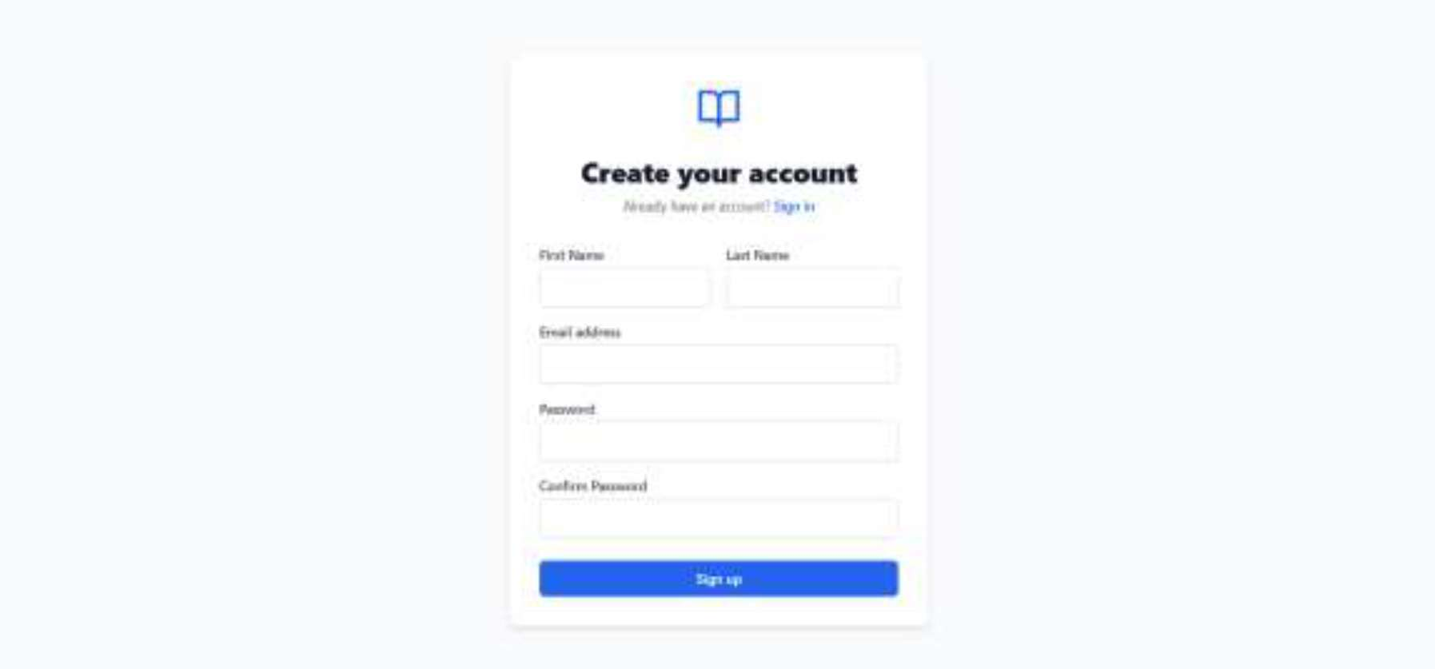

Standard registration fields (email, password), with a "Signup" button.

Fig 3.2.2 Sign Up Page

Note Sharing Module:

After logging in, students can upload notes.

Notes are tagged with subjects and descriptions.

Other users can view shared materials.

Uploads are stored in Supabase and fetched dynamically.

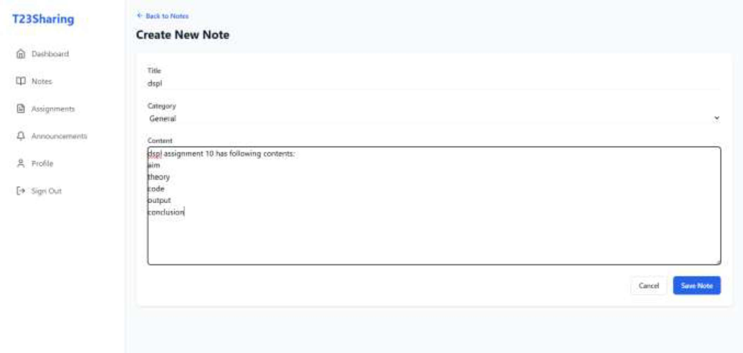

A form to create/share a note with title and description fields.

Fig 3.3.1 Create Notes Page
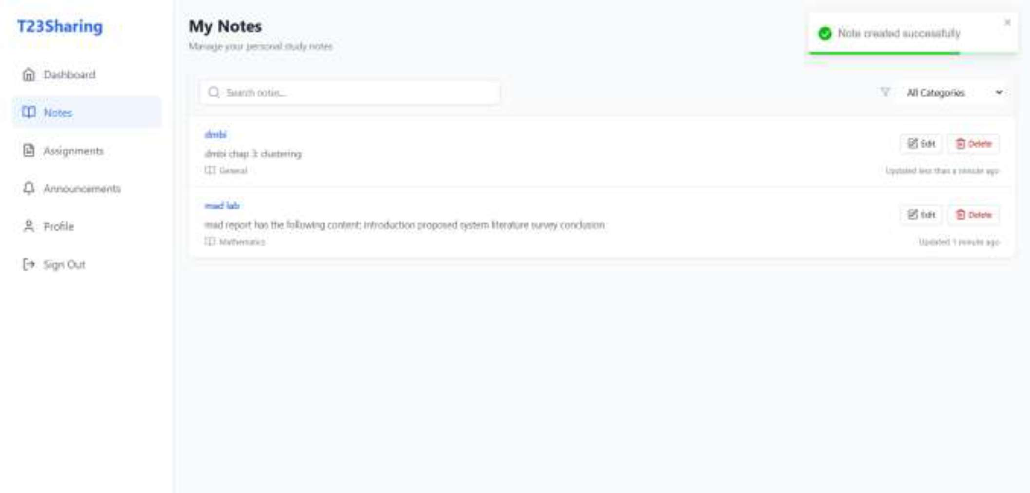

Has multiple notes visible (with titles, descriptions, usernames).

Fig 3.3.2 Notes Page

Assignment Module:

The Assignment Module in Academic content sharing web app is a crucial component designed to help students manage and submit assignments efficiently. It provides features for uploading assignments, tracking their status (Pending / Submitted / All), and maintaining an organized submission history. The module ensu
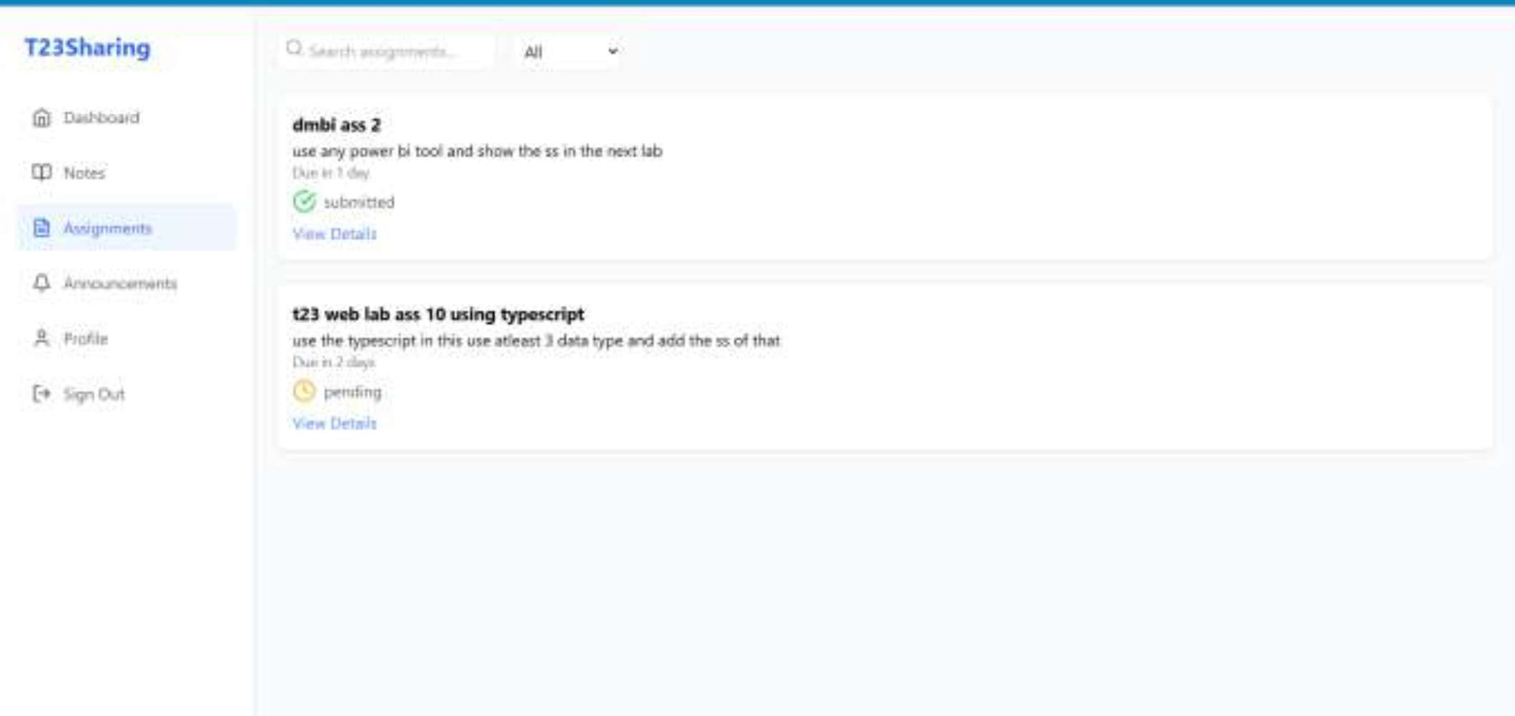

This is an assignment page where we can see the pending/submitted/all types of assignment added by the faculty

Fig 3.4.1 Assignment Page

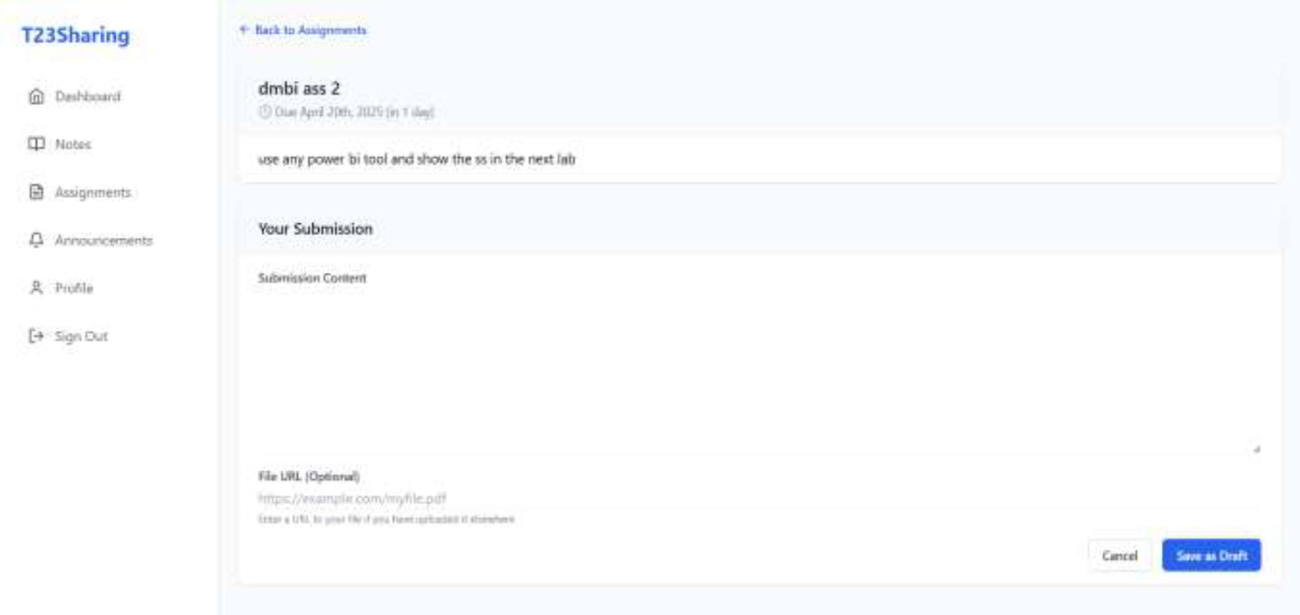

Here the faculty adds an assignment and is displayed on the assignment page and the student submits it.

Fig 3.4.2 Assignment Detail Page

Announcement Page:

Users can post announcements like:

    - Posts include a timestamp and user name.
    - Real-

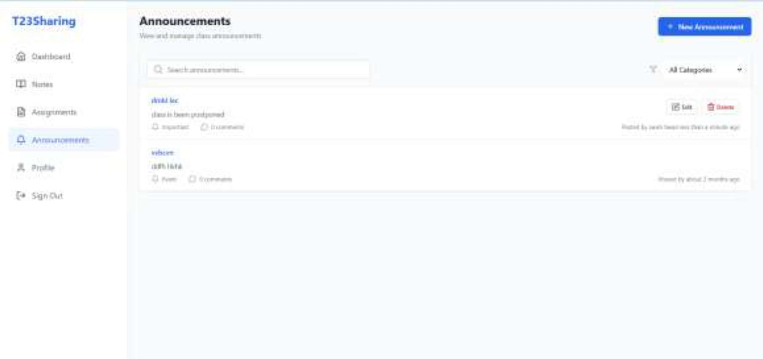
Displays an official announcement added by a student .
Fig 3.5.1 Announcement Page
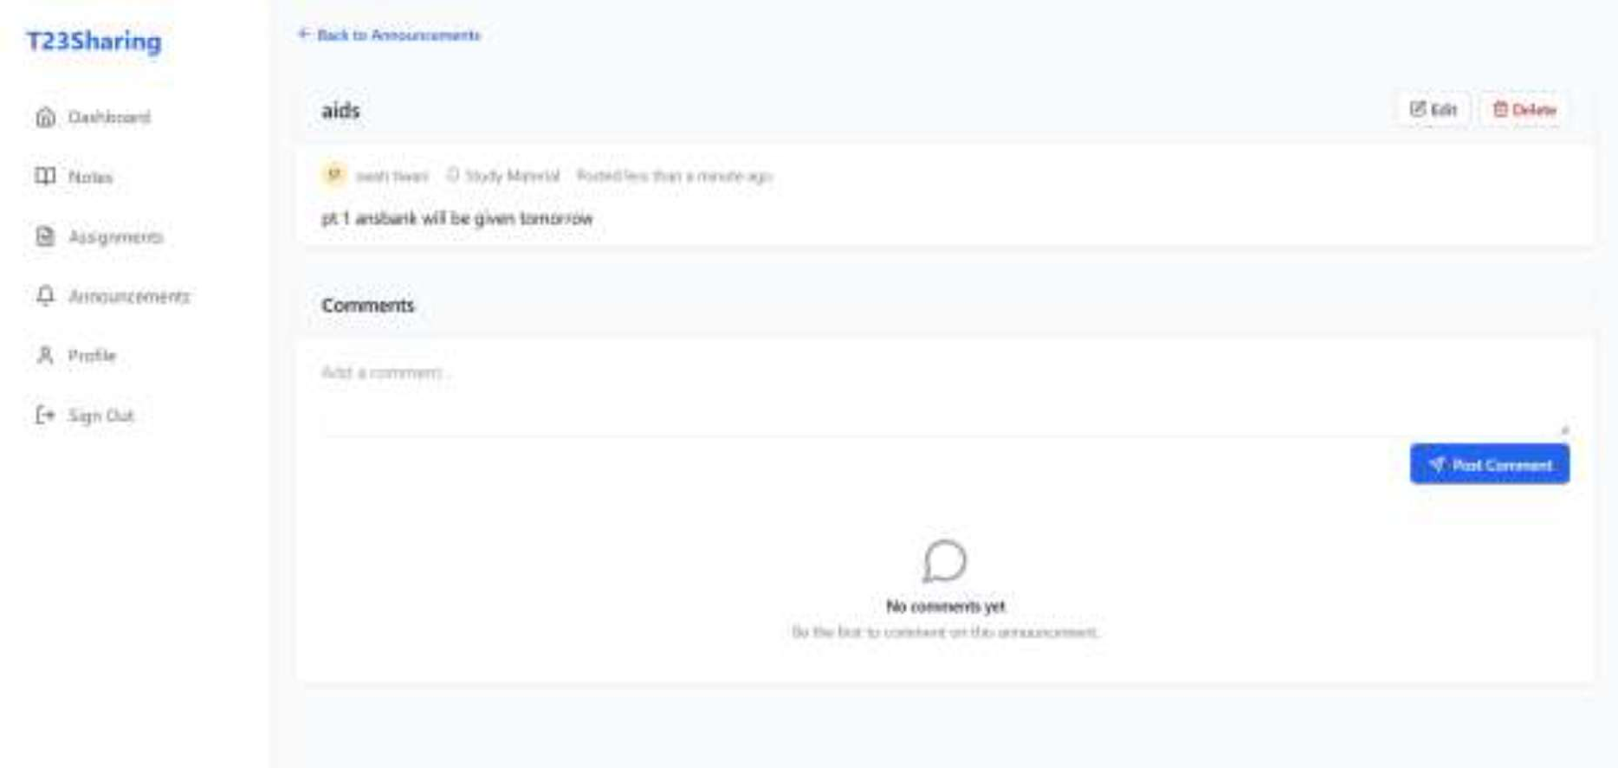
Here the announcement added is been displayed and also the time with the username who has added the announcement.
Fig 3.5.2 Announcement Feed Page

Profile Information Module:

The Profile Module in Academic content sharing web app allows each student to manage and view their personal account details. This screen is accessible from the sidebar navigation and is designed to be clean, minimal, and intuitive. It plays a critical role in account personalization while maintaining security by limiting editable fields.
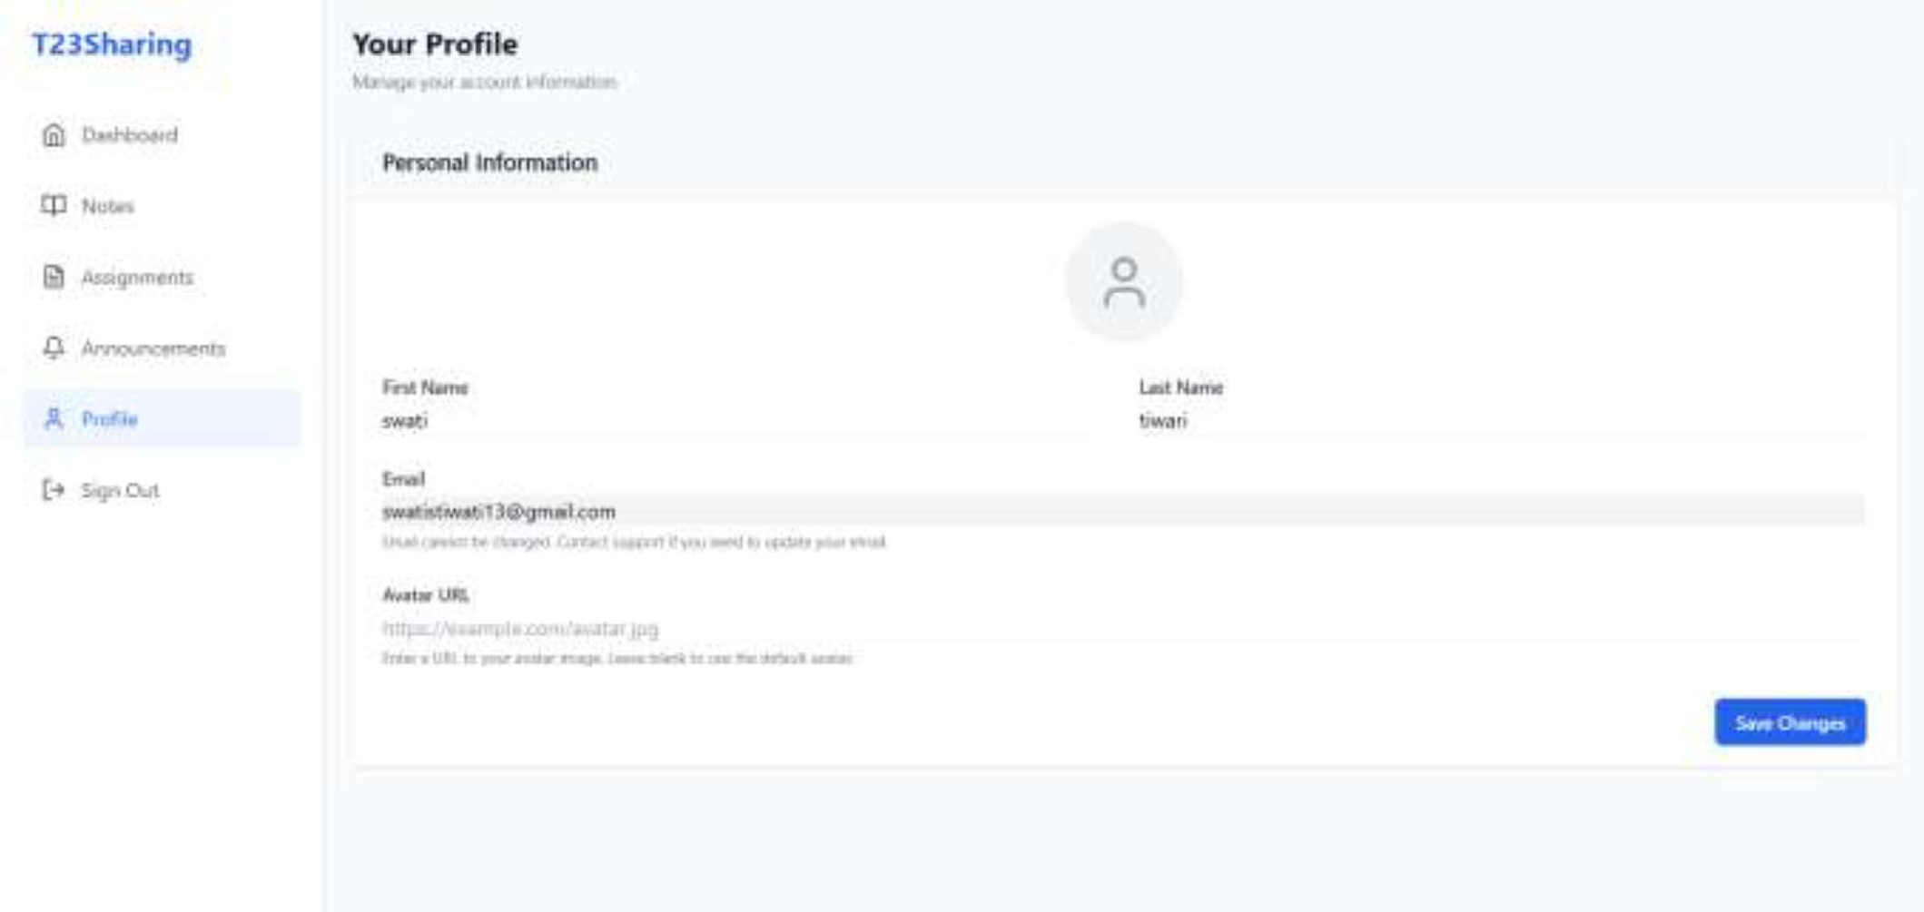

Here all the information is been displayed about the student who is using the app.

Fig 3.6.1 Profile Page

Real-Time Data with Supabase:

All data (notes and announcements) are synced instantly across users real-time listeners notify clients of any update
Ensures collaborative experience without page refreshes
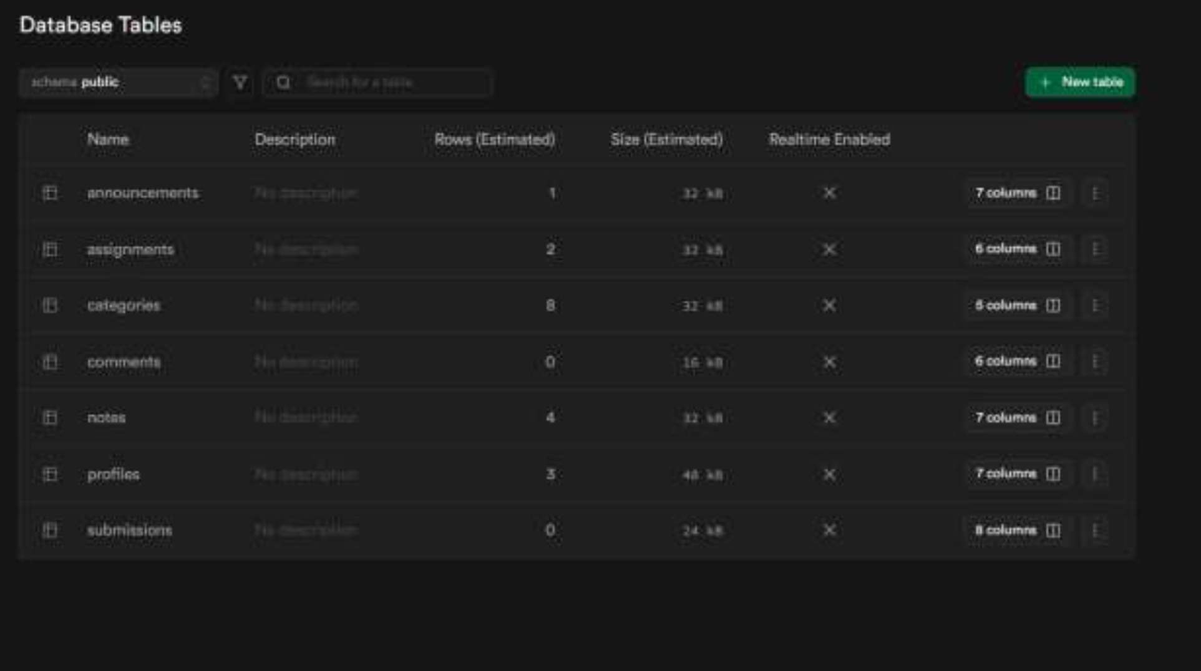

Fig 3.7.1 Database

Profile Purpose:
Manages user account details and links them to actions in the app such as posting notes, comments, or submissions. This table extends the default Supabase Auth system.

Used For:

Storing additional user info like first name, last name, avatar URL.
Displaying user identity across the app (e.g., author names on notes or comments).
Identifying the creator of notes, announcements, and assignment submissions.

Notes Purpose:
Stores shared academic notes uploaded by users for the T23 batch.

Used For:

Displaying the list of notes in the feed.
Allowing students to upload PDFs, docs, or images as lecture notes.
Tracking who uploaded which note.

Announcement Purpose:
Stores official announcements such as class cancellations, reminders, and updates.

Used For:

Displaying real-time announcements to all users.
Sending urgent information to the entire batch.
Announcements can only be made by selected users or admins.

Submissions Purpose:
Handles student assignment uploads and tracks their submission status.

Used For:

Showing which assignments are pending or completed.
Uploading assignment files (PDFs, DOCs, etc.).
Filtering assignments as Submitted or Pending in the UI.

Comments Purpose:
Stores comments made on shared notes or announcements.

Used For:

Allowing users to interact under notes (ask doubts, appreciate, discuss).
Creating a collaborative learning environment.
Linking each comment to its note and its author.

Categories Purpose:
Provides tagging or classification of notes and assignments into subjects or topics.

Used For:

Grouping notes (e.g., "DSA", "DBMS", "Flutter").
Filtering notes by category in the frontend.
Maintaining a clean structure and discoverability of content.

CONCLUSION

Academic content sharing web app bridges the gap between academic collaboration and digital convenience. It provides a secure, structured, and efficient platform for students to share notes and make announcements. The app leverages powerful backend services and delivers a seamless cross-platform experience through its Flutter and PWA versions.

Key Outcomes:

Instant and organized access to academic materials
Streamlined student communication
Scalable and flexible design using modern frameworks

Future Enhancements:

AI-based personalized note recommendations
Admin dashboard for monitoring uploads
Reminders and notifications for important updates
Versioning system for notes

REFERENCES

[1] D. Bonafilia, B. Tellman, T. Anderson, and E. Issenberg, “Sen1Floods11: A Georeferenced Dataset to Train and Test Deep Learning Flood Algorithms for Sentinel-1,” Proceedings of the IEEE/CVF Conference on Computer Vision and Pattern Recognition (CVPR) Workshops, 2020, pp. 210–211. CVF Open Access

[2] R. Gupta, B. Goodman, N. Patel, R. Hosfelt, S. Sajeev, E. Heim, J. Doshi, K. Lucas, H. Choset, and M. Gaston, “Creating xBD: A Dataset for Assessing Building Damage from Satellite Imagery,” Proceedings of the IEEE/CVF Conference on Computer Vision and Pattern Recognition (CVPR) Workshops, 2019, pp. 10–17. CVF Open Access

[3] P. Ge, H. Gokon, and K. Meguro, “A Review on Synthetic Aperture Radar-Based Building Damage Assessment in Disasters,” Remote Sensing of Environment, vol. 240, p. 111693, 2020. ScienceDirect

[4] W.-N. Kuo and S.-Y. Lin, “Multimodal Models for Assessing Earthquake-Induced Building Damage Using Metadata and Satellite Imagery,” Journal of Building Engineering, vol. 111, p. 113467, 2025. ScienceDirect

[5] S. Selvakumaran et al., “Improving Operational Use of Post-Disaster Damage Assessment for Urban Search and Rescue by Integrated Graph-Based Multimodal Remote Sensing Data Analysis,” Progress in Disaster Science, vol. 25, p. 100404, 2025.

